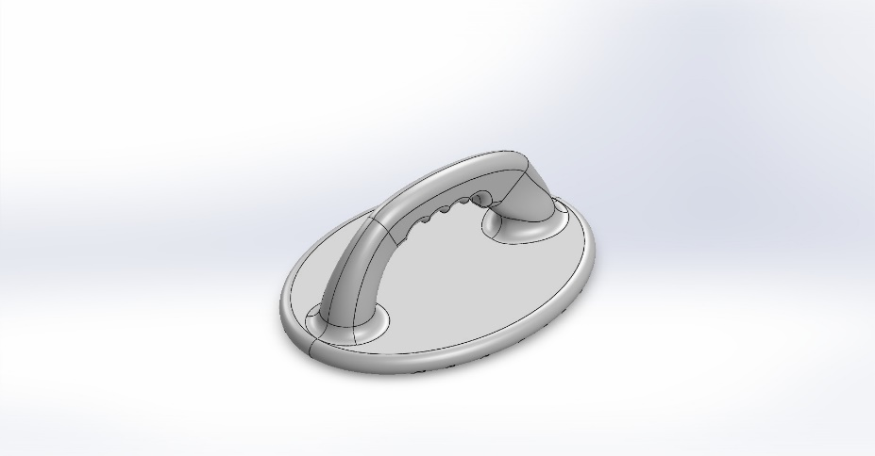
  Simulation of Pushup
  Date: Friday, June 27, 2025
  Designer: Solidworks
  Study name: SimulationXpress Study
  Analysis type: Static
  Table of Contents
  Description 1
  Assumptions 2
  Model Information 2
  Material Properties 3
  Loads and Fixtures 3
  Mesh information 4
  Study Results 6
  Conclusion 8

Description
No Data

Assumptions

Model Information

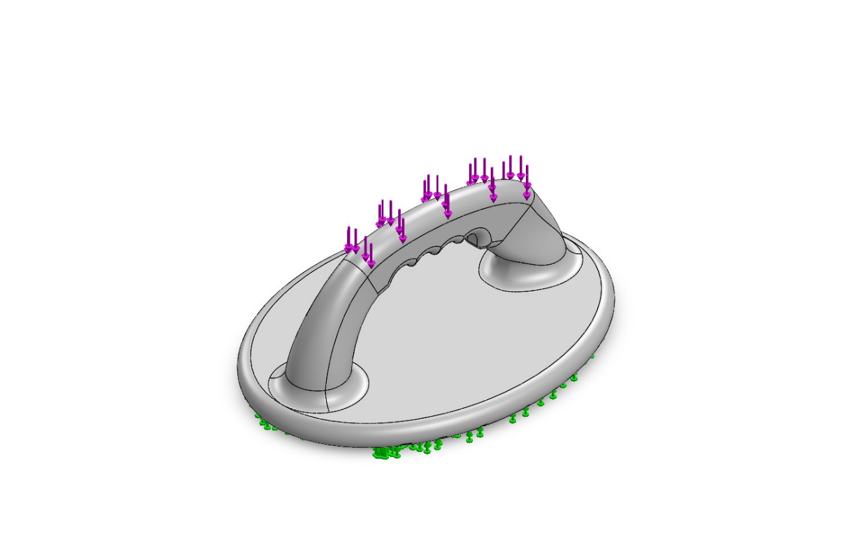
Model name: Pushup
Current Configuration: Default
Solid Bodies
Document Name and Reference | Treated As | Volumetric Properties | Document Path/Date Modified
Pattern  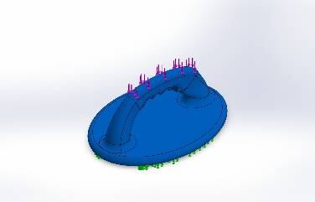 | Solid Body | Mass:1.54622 kg  Volume:0.00151625 m^3  Density:1,019.77 kg/m^3  Weight:15.153 N | C:\Users\Behdad\Desktop\SolidWorks\Projects\Pushup\Pushup.SLDPRT  Jun 27 19:04:23 2025

Material Properties
Model Reference | Properties | Components
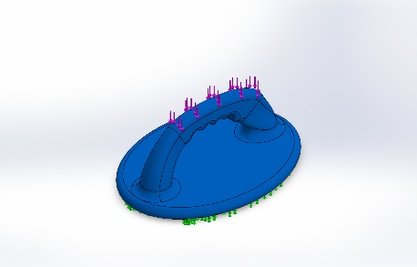 |  | SolidBody 1(Pattern)(Pushup)
  Name: | ABS
  Model type: | Linear Elastic Isotropic
  Default failure criterion: | Unknown
  Tensile strength: | 3e+07 N/m^2

Loads and Fixtures
Fixture name | Fixture Image | Fixture Details
Fixed-2 | 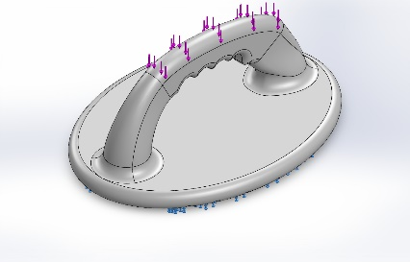
  Entities: | 11 face(s)
  Type: | Fixed Geometry

Load name | Load Image | Load Details
Force-2 | 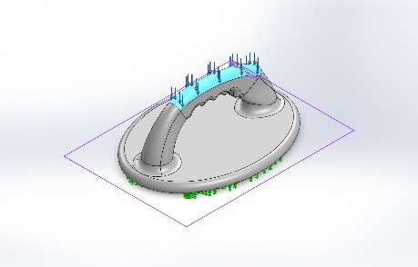
  Entities: | 1 face(s), 1 plane(s)
  Reference: | Top Plane
  Type: | Apply force
  Values: | ---, ---, -,450 N

Mesh information
Mesh type | Solid Mesh
Mesher Used: | Standard mesh
Automatic Transition: | Off
Include Mesh Auto Loops: | Off
Jacobian points for High quality mesh | 16 Points
Element Size | 5.74226 mm
Tolerance | 0.287113 mm
Mesh Quality | High

Mesh information - Details
Total Nodes | 92821
Total Elements | 60486
Maximum Aspect Ratio | 21.905
% of elements with Aspect Ratio < 3 | 99.1
Percentage of elements with Aspect Ratio > 10 | 0.0132
Percentage of distorted elements | 0
Time to complete mesh(hh;mm;ss): | 00:00:13
Computer name: | AQUILA
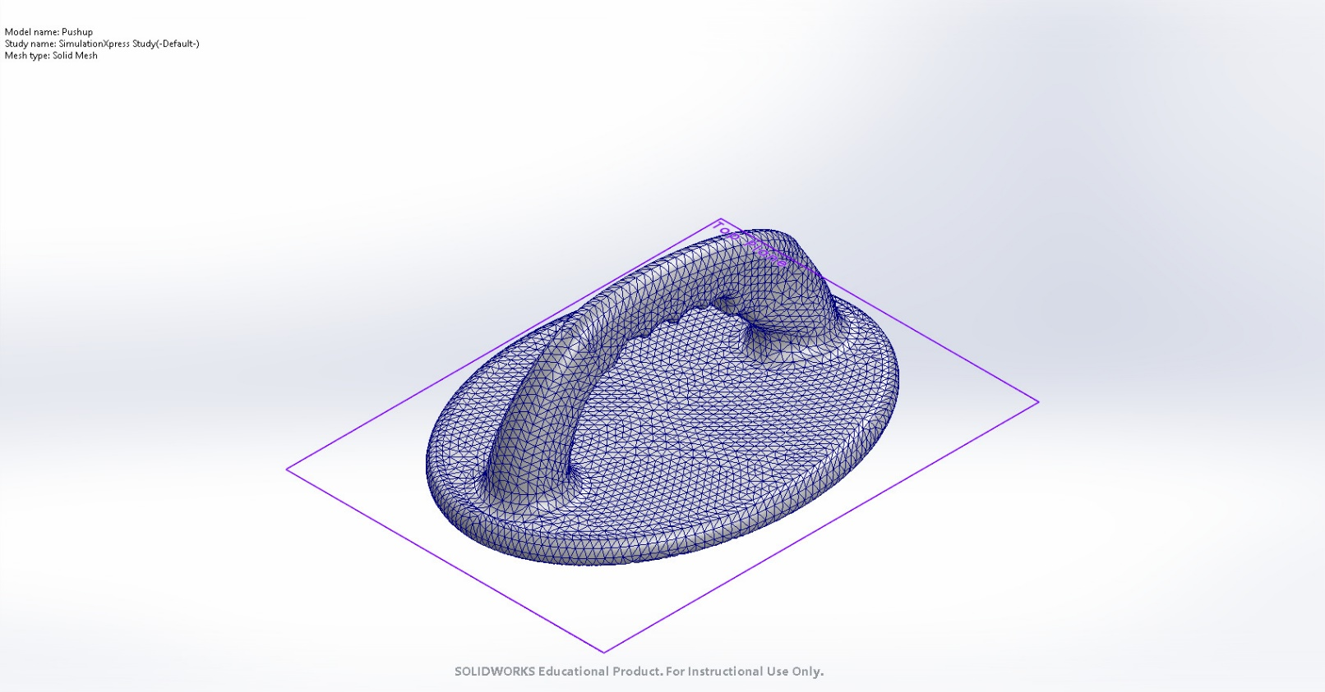

Study Results

Name | Type | Min | Max
Stress | VON: von Mises Stress | 4.704e+00N/m^2  Node: 60594 | 8.638e+05N/m^2  Node: 1069
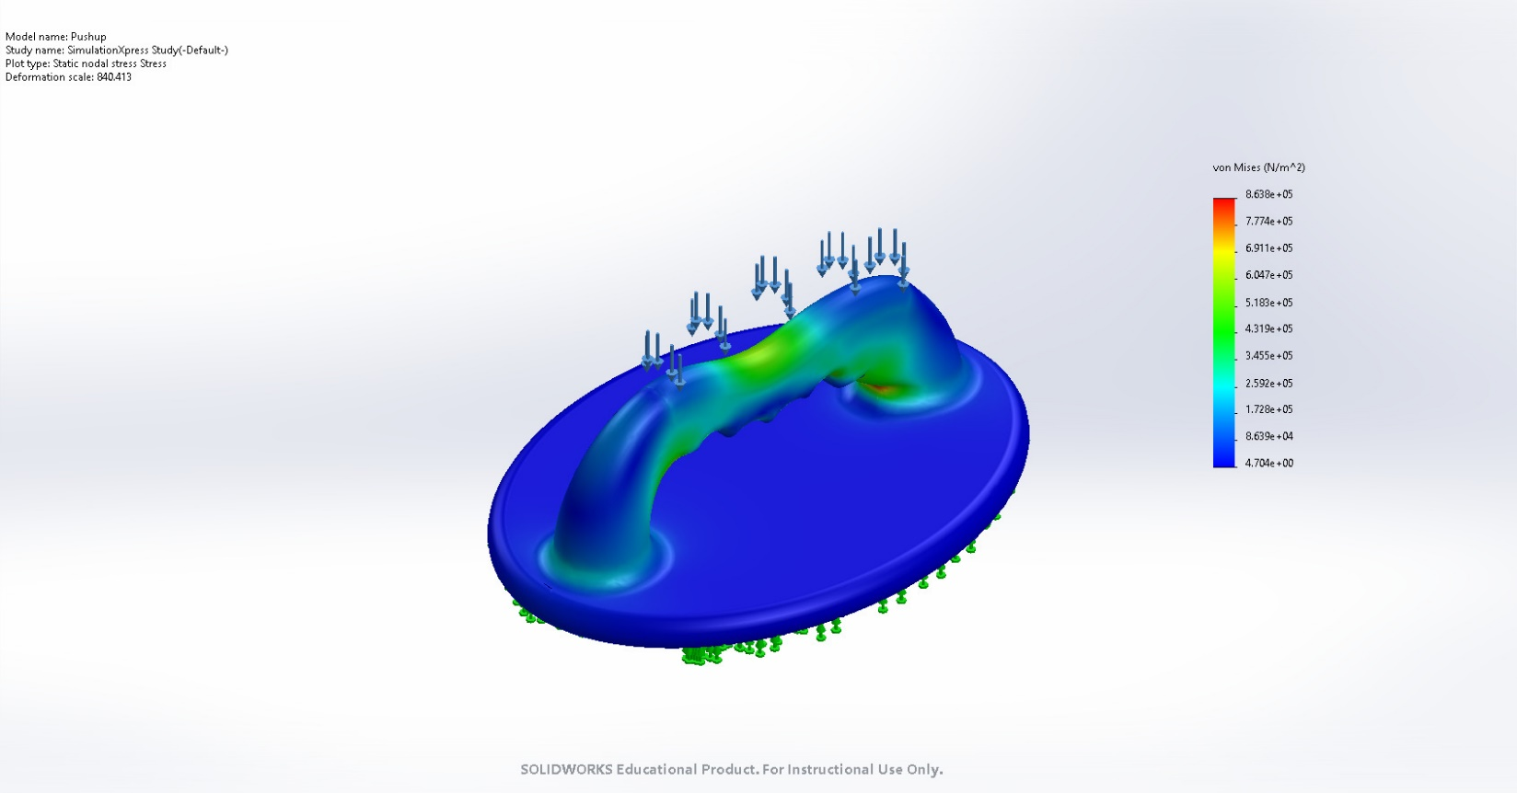
Pushup-SimulationXpress Study-Stress-Stress

Name | Type | Min | Max
Displacement | URES: Resultant Displacement | 0.000e+00mm  Node: 268 | 3.887e-02mm  Node: 3823
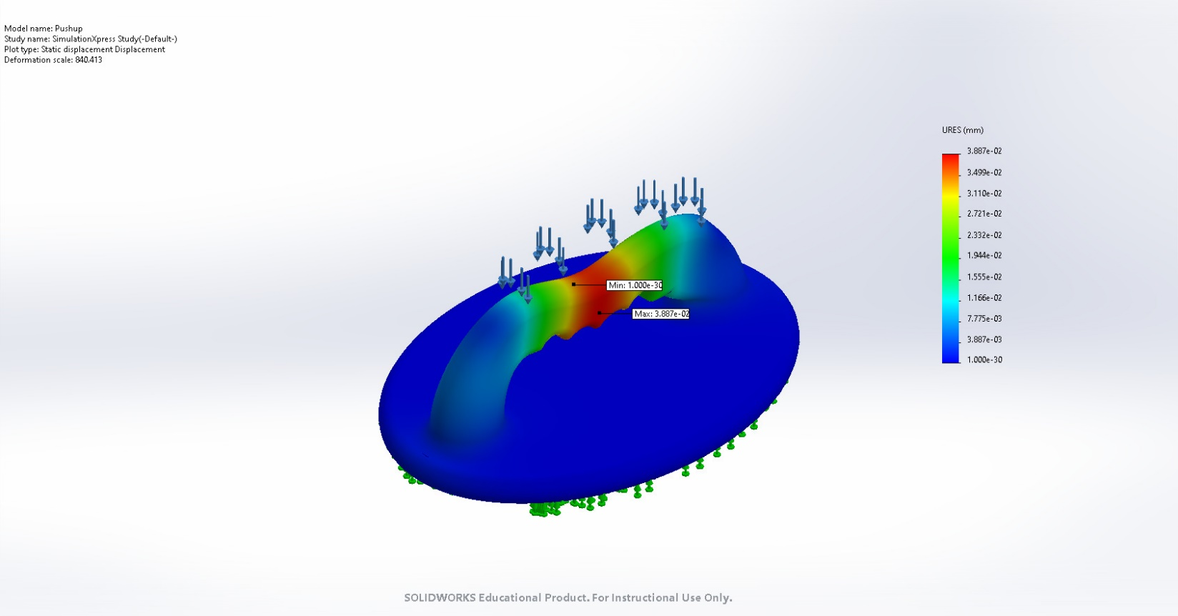
Pushup-SimulationXpress Study-Displacement-Displacement

Name | Type
Deformation | Deformed shape
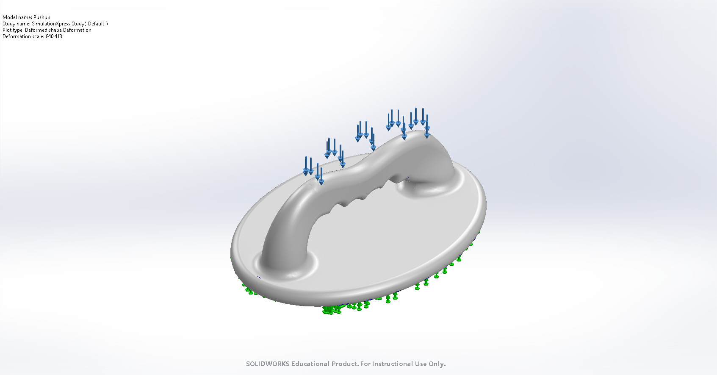
Pushup-SimulationXpress Study-Displacement-Deformation

Conclusion

